Gabrielle Armetta

Professor Kevin Ryan

CS 110

13 December 2020

Final Project Report

* **Section One; “Overview and Summary of Project”**

Using PyCharm and 3 CSV files, I created a Python program that prompts the user to enter a number 1, 2, or 3, which corresponds to the stocks of Apple, Tesla, and Facebook, respectively. Once the user enters their number of choice, the program will ask the user to enter any date from January 2, 2019 to December 31, 2019. Then, the program will output a row of data of the chosen stock on the user’s chosen date of the year. (After my if-elif-else decision structure, I closed the main [not pictured]).

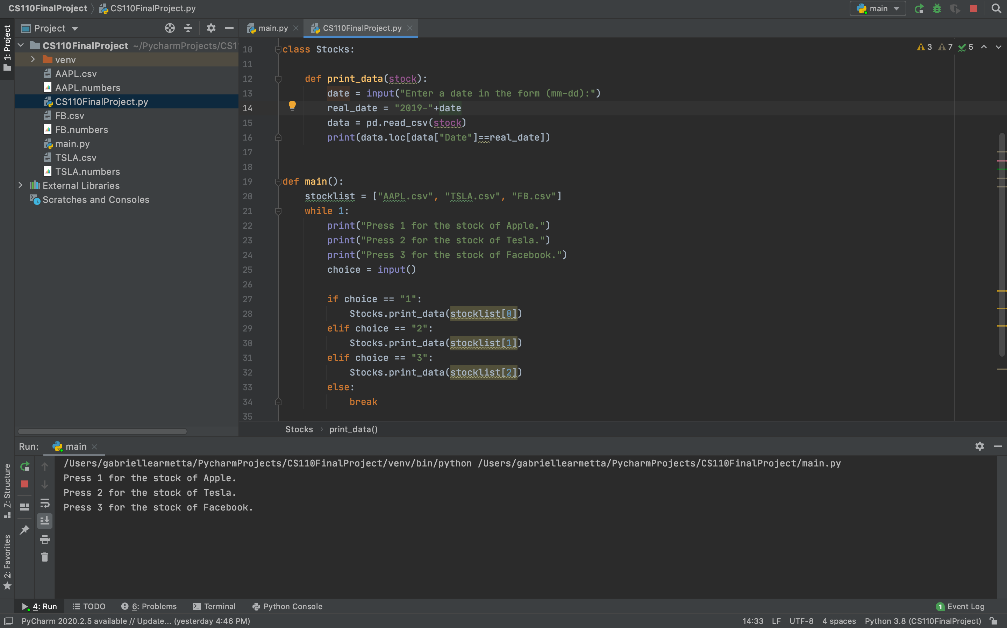

For example, if the user enters 1, the program will then prompt you to enter a date in the form of “mm-dd”. If the input is the number 1 and the date entered is 11-04, it will output the date, the opening and closing stock prices, high and low stock prices, the adj. close, and volume for the AAPL stock on the date November 4, 2019.

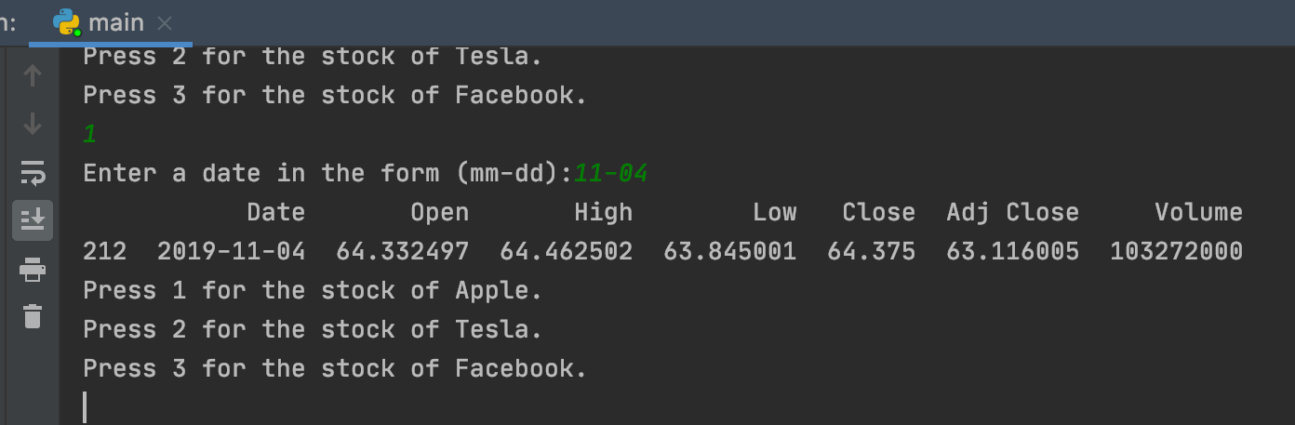

* **Section Two; “Target Audience”**

The target audience for my program can be anyone working in the financial sector dealing with stocks such as hedge fund managers, banks, stock analysts, and even individuals looking to become interested and invest in the stock market. The user of this program can see the change in the stock price per share over the entire year of 2019, and even look at smaller increments by entering several dates to see the difference in the stock prices of AAPL, TSLA, and FB over months, weeks, or even days.

* **Section Three; “Specific Programming Techniques Used”**

In my Python program, I utilized programming techniques such as importing CSV files, importing pandas library, classes, lists, functions, and if-elif-else decision structures. In order for my program to have the data of these stocks, I imported the CSV files for Apple, Tesla, and Facebook stocks for 2019 from Yahoo Finance. To begin coding my program, I imported the pandas library, which stands for “Python Data Analysis Library”, which takes data like a CSV file and creates a Python object with rows and columns called data frames. I created the class “Stocks” to house the “print_data” function, which has the user enter the date in the form “mm-dd”. Then, the program opens the file, searches the file for that specific date using a command from the pandas library, and then prints the data. I defined my list as “stocklist”, and listed the three stocks I utilized for this program. Next, I created a while loop so the program would run continuously, unless prompted to stop. Last, I used the if-elif-else decision structure. If the user chose 1, 2, or 3, the program would open the corresponding stock file. If anything else was entered, the program is stopped.

* **Section Four; “Challenge(s)”**

The major challenges I came across while writing this program include having the “print_data” function accept the string “stocklist” as an input, having the program read the CSV files, and having the program find and print the specific row that the entered date corresponds to. For the first challenge, I had to make the “self” of the function act as the mediator between the function and stocklist. I changed “self” to “stock” to make the program easier to read. The function would then accept “stock” as the input. Next, I imported the pandas library and read the commands to find the one that would suit my requirements. For the final problem, I created a command that would add “2019-” to the beginning of the inputted date so the input would always be in the year 2019, which is the year that is the start of every row.

* **Section Five; “Future Extensions”**

New extensions and improvements to my program could include adding the CSV files of each stock in the S&P 500 to compare their stock performances over the entire year, extending the period of time of the stock data, calculating the percent change of a stock between multiple dates, and only showing data for exclusive columns such as the maximum and minimum stock prices for the date.